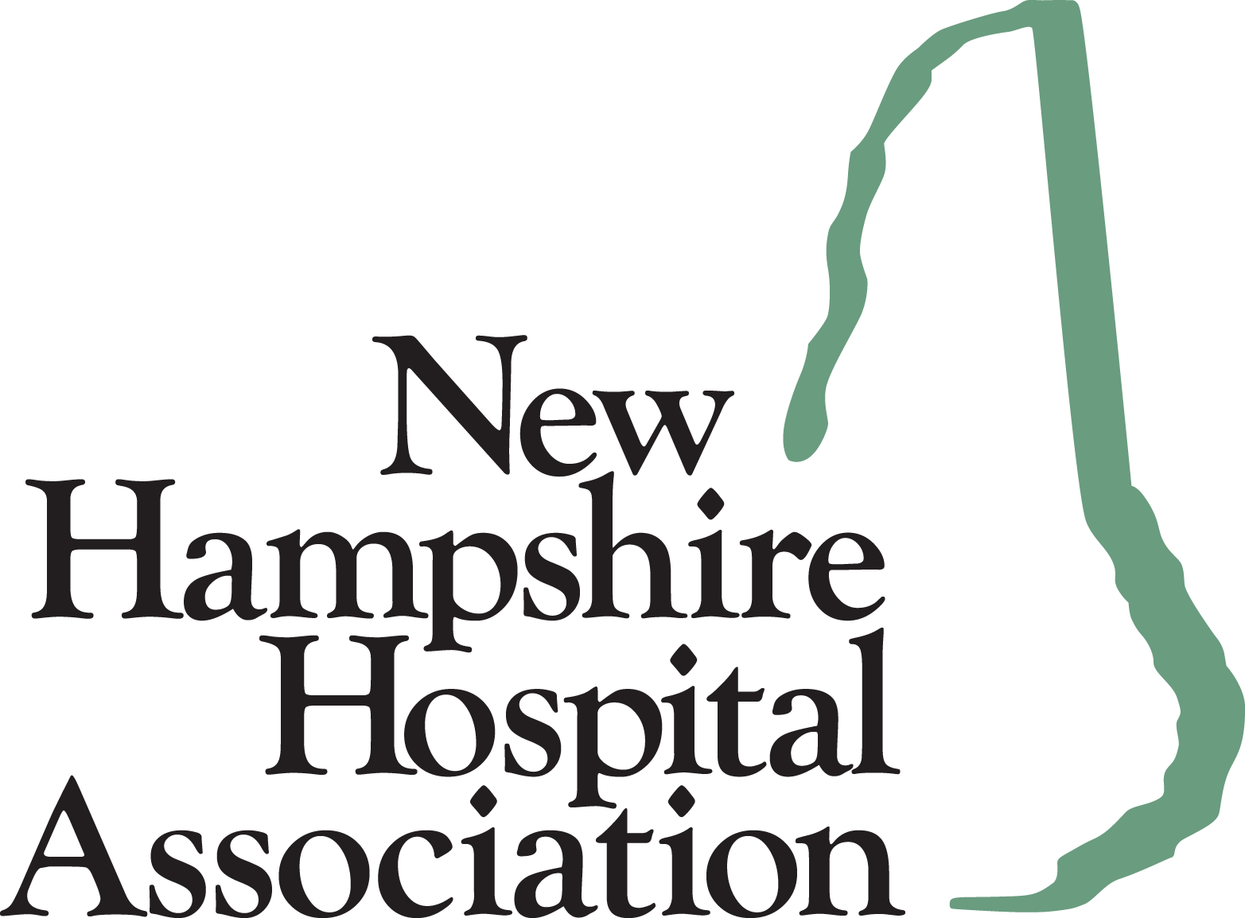

For Immediate Release Contact: Tammy Boucher
January 10, 2024 (603) 415-4255

As Respiratory Viruses Increase, Hospitals Report Nearly 100% Capacity
New Hampshire Hospital Association Encourages Vaccination and Other Preventative Measures

CONCORD, NH - As we enter the new year, hospitals have seen an increased number of patients and staff with respiratory viruses, including the flu, COVID-19 and RSV. Added to an already high level of demand, workforce shortages and a continued inability to discharge patients due to constraints being experienced in long-term care and home care, hospitals are busy, and beds are full. Just last week, hospitals from across the state reported overall capacity at nearly 100%, according to the New Hampshire Hospital Association (NHHA).

As a result, patients across the state may see some changes the next time they visit a hospital or health care facility. Some hospitals have begun to implement changes to their infection prevention measures such as asking patients and visitors to wear a mask when in certain patient care areas. “The decision to change the use of masks in health care settings is driven by data and guidance from health care experts. That data and expert guidance ensures hospitals and health care facilities are safe places for patients to receive both routine and emergency care,” said NHHA President Steve Ahnen. Individuals with weakened immune systems, patients suffering from respiratory infection and people who were infected with COVID-19 within the last 10 days are always encouraged to wear masks.

The New Hampshire Hospital Association and its members and partners encourage everyone to remain vigilant about basic health care and hygiene, such as regular handwashing to stay healthy. Recommendations include making sure annual physicals have been scheduled and vaccines and immunizations are current, including vaccinations for the flu, RSV and COVID-19. CDC recommendations and best practices should be followed, such as staying home when not feeling well, testing if you have symptoms, seeking therapeutics if testing positive and wearing masks in crowded indoor spaces to help prevent the spread of infection. People are encouraged to visit https://nhstayswell.org/ for additional information on how to stay healthy this season.

Evidence-based public health measures such as masking, testing, vaccines, and other mitigation methods are still important tools in the fight against COVID-19 and other illnesses. There is no one solution that can completely eliminate the risk of spreading infections, but when layered together, these interventions can have a significant impact on the rate of infections, hospitalizations, and deaths in New Hampshire.

“Working together, utilizing the tools, resources and information we have gathered over the past several years, we can and will get through this,” said Ahnen.

About the New Hampshire Hospital Association
Hospitals have been collaborating through the New Hampshire Hospital Association (NHHA) since 1934. The association's mission is to provide leadership through advocacy, education, and information in support of its member hospitals and health care delivery systems as they strive to improve the health of the patients and communities they serve. www.nhha.org

