
US Congressional Delegation – New Hampshire

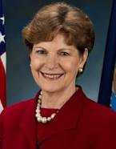
Senator Jeanne Shaheen
506 Hart Senate Office Building
Washington, DC 20510
(202) 224-2841
Vic Goetz – Health Legislative Assistant - Victor_Goetz@shaheen.senate.gov
Madison Lightfoot – NH outreach
Madison_lightfoot@shaheen.senate.gov
Meaghan D’Arcy – Scheduler - Scheduler_Shaheen@Shaheen.Senate.Gov

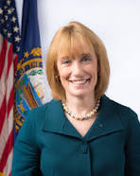
Senator Maggie Hassan
324 Hart Senate Office Building
Washington, DC 20510
(202) 224-3324
Scott Levy – Health Legislative Director scott_levy@hassan.senate.gov
Pam Walsh - Pamela_Walsh@hassan.senate.gov
Catherine George – Scheduler – Catherine_George@hassan.senate.gov or
scheduling@hassan.senate.gov (in Catherine’s absence)


Rep. Chris Pappas, District 1
323 Cannon House Office Building
Washington, DC 20515
(202) 225-5456
Paige Henderson – Legislative Assistant - Paige.Henderson@mail.house.gov
Christian Seaholtz – NH outreach - Christian.seasholtz@mail.house.gov Alexander Siegal – Scheduler - Alexander.Siegal@mail.house.gov
Kari Thurman – NH District Office - kthurman@chrispappas.org

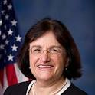
Rep. Ann McLane Kuster, District 2
320 Cannon House Office Building
Washington, DC 20515
(202) 225-5206
Marisa Salmenne - Legislative Director - Marisa.Salemme@mail.house.gov
Lizzy Burke – Health Legislative Asst - lizzy.burke@mail.house.gov
Amy Slattery – NH Constituent Service and Outreach Coordinator - Amy.Slattery@mail.house.gov (603) 226-1002
Miriam Young – Scheduler – miriam.young@mail.house.gov

